Experiment 4 – Introduction to SQL and DDL

Objective
- Familiarize students with the SQL DDL commands
- Enable students to use the basic DML commands (in order to check the working of above DDL commands)

SQL (Structured Query Language)
SQL commands can be broadly categorized under the following four types:

- DDL
Data Definition Language (DDL) statements are used to define the database structure or schema. Some examples:
CREATE - to create objects in the database
ALTER - alters the structure of the database
DROP - delete objects from the database
TRUNCATE - remove all rows from a table
- DML
Data Manipulation Language (DML) statements are used for managing data within schema objects. Some examples:
SELECT - retrieve data from the database
INSERT - insert data into a table
UPDATE - updates existing data within a table
DELETE - deletes all records from a table, the space for the records remain

- DCL
Data Control Language (DCL) statements. Some examples:
GRANT - gives user's access privileges to database
REVOKE - withdraw access privileges given with the GRANT command
- TCL
Transaction Control (TCL) statements are used to manage the changes made by DML statements. It allows statements to be grouped together into logical transactions.
COMMIT - save work done
SAVEPOINT - identify a point in a transaction to which you can later roll back
ROLLBACK - restore database to original since the last COMMIT

Exercise1: Practice DDL commands using SQL server management studio

Step1: Login to your database
- Open SQL server management studio via Start->Program Files ->SQL server 2012 -> SQL server management studio
  - enter your server name as “localhost” username as “sa” password as “fstky2e4mdt” or use server name as “172.16.1.254” and password as “12345678” depending on what you used in the last lab.
- Select your database

Step2: Create a schema (Not required)
- Click on “New Query”
- In the window (Query Manager) that comes up run the following command
Use [your_own_DB_created_in_lab3]
create schema lab4

Step3: Create table command
Use only table name, like create table School, instead of create table lab4.school

- Run the following statement in your own database
CREATE TABLE lab4.School(
schID [int] NOT NULL,
schName [varchar](50) NULL,
schdeanID [int] NULL,
)

CREATE TABLE lab4.Staff(
staffID [int] NOT NULL,
staffName [varchar](50) NULL,
staffRole [varchar](50)
)
- Refresh your database and verify the results from designer on left

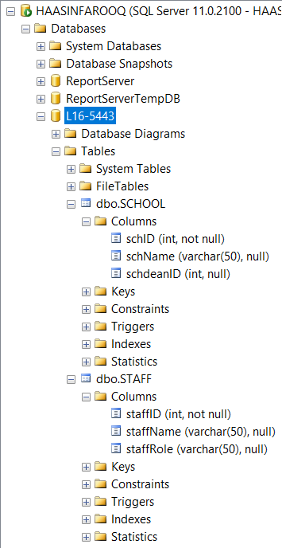

Step3: Drop table command
- Run the following statement in your own database

drop table lab4.school

- Refresh your database and verify the results from designer on left

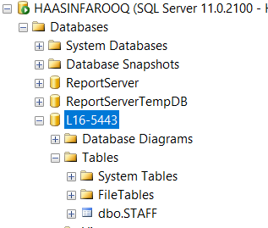

Step4: Primary key on a new table
- Recreate the table dropped in step3, this time with the primary key constraint in place by running the following command
CREATE TABLE lab4.Staff(
staffID [int] NOT NULL,
staffName [varchar](50) NULL,
staffRole [varchar](50),
constraint staffPK primary key (staffId)
)
- Refresh your database and verify the results from designer on the left by expanding Keys under Staff table

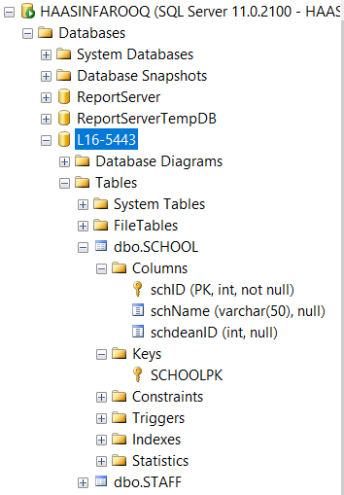

Step5: Primary key on an existing table via ALTER table command

- Using your own database run the following command

Alter TABLE lab4.School add constraint schPK primary key(schID)

- Refresh your database and verify the results from designer on the left by expanding Keys under School table

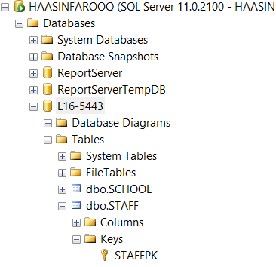

Step6: Set Foreign Key on new table
- Drop table school (you know how to do that now)

- Recreate the table school by running the following statement
CREATE TABLE lab4.School(
schID [int] NOT NULL primary key,
schName [varchar](50) NULL,
schdeanID [int] NULL,
constraint deanFK foreign key (schdeanID) references lab4.Staff(staffId)
)

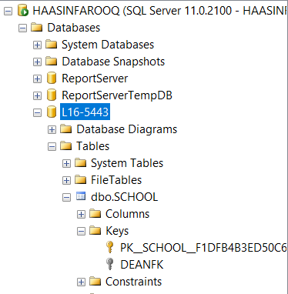

Step7: Drop Foreign Key constraint via Alter table command
- Using your own database run the following command
Alter table lab4.school drop constraint deanFK
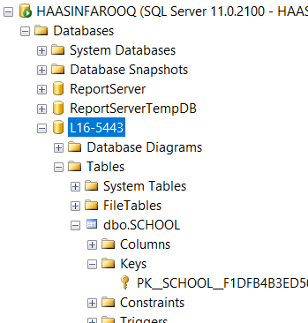

Step8: Add Foreign Key constraint to an existing table via Alter table command
- Using your own database run the following command
Alter table lab4.school add constraint deanFK foreign key (schdeanID) references lab4.Staff(staffId)
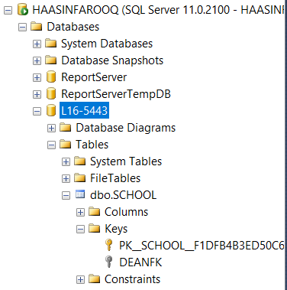

Step9: Add Foreign key constraint to set behavior on delete/update
- Drop the deanFK foreign key constraint added in step8 above
- Recreate the foreign key constraint on school table to set behavior on update and delete by running the following command
Alter table lab4.school add constraint deanFK foreign
key(schdeanID)references staff(staffID)
on delete set null on update cascade

Step10: Check the behavior of the foreign key constraint set above by inserting a few rows in both the tables and then deleting and updating rows in Staff table

- Run the following insert commands to populate the two tables
Insert into lab4.staff values (101, ‘Ahmed’, ‘Principal’)
Insert into lab4.staff values (102, ‘Ali’, ‘Head Teacher’)
Insert into lab4.staff values (103, ‘Salman’, ‘Teacher’)
Insert into Lab4.staff(staffName, staffId) values (‘Fatima’, 104)

Insert into lab4.school values (1, ‘DPS’, 101)
Insert into lab4.school values (2, ‘LGS’, 102)
Insert into lab4.school values (3, ‘BeaconHouse’, 103)

- Select Data from the two tables by running the following commands
Select * from lab4.staff
Select * from lab4.school

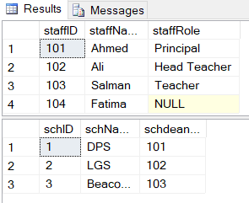

- Update Data in Staff table by running the following command
Update lab4.staff set staffId=106 where staffId=103

Check the behavior on update by selecting data from the tables
Select * from lab4.staff
Select * from lab4.school

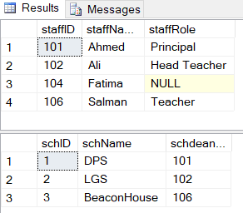

- Delete Data in Staff table by running the following command
Delete from lab4.staff where staffId=102

Check the behavior on delete by selecting data from the tables
Select * from lab4.staff
Select * from lab4.school
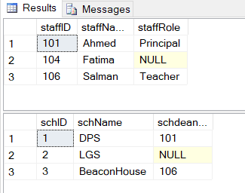

Step11: Add column to an existing table
Alter table lab4.school add schAddress varchar(100)
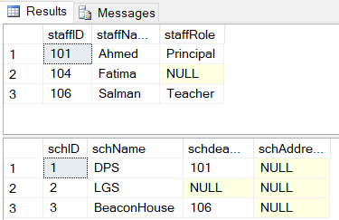

Step12:Remove column from an existing table
Alter table lab4.school drop column schAddress

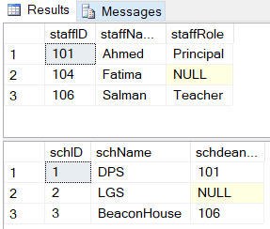

Step13: TRUNCATE table
TRUNCATE removes all rows from a table while structures still persists.
- Insert 5 new rows in school table
- Now execute truncate command as shown
truncate table lab4.school
- select data from school table

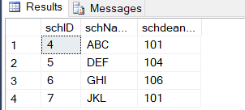

PostLab

director
did | name | bestRev

movie
mid | mname | Directed_by

Given the relational model above:
- Give the table creation statements with all constraints in place

use [postlab4]
create table director
(
did int not null,
name varchar (20) not null,
bestRev varchar (30),
constraint DIRPK primary key (did)
);

create table movie
(
mid int not null,
mname varchar (20) not null,
Directed_by int,
constraint MOVPK primary key (mid),
constraint MOVFK foreign key (Directed_by) references director (did)
);

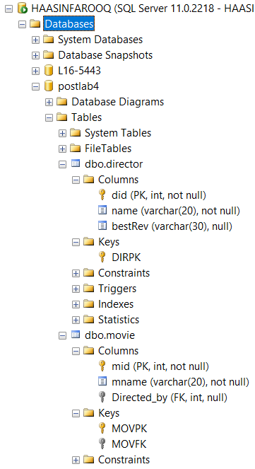
- Give the DDL statements to drop the primary key and foreign key constraints in real time

alter table movie drop constraint MOVFK
alter table movie drop constraint MOVPK
alter table director drop constraint DIRPK

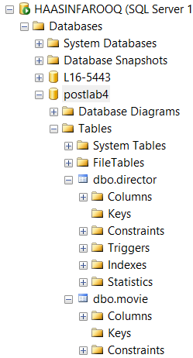

- Explore how you can set primary key constraints on the director table using GUI provided by SQL Server, include screen shots
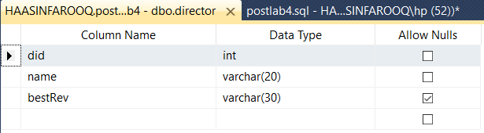

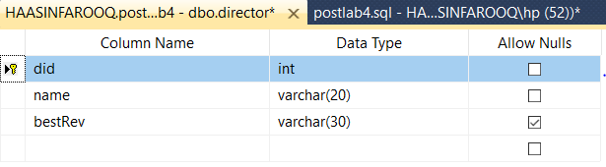

- Explore how you can set foreign key constraints between tables above by using the GUI provided by SQL Server, include screen shots

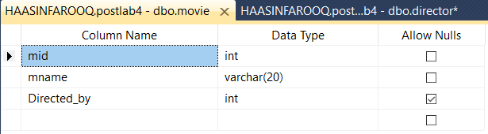

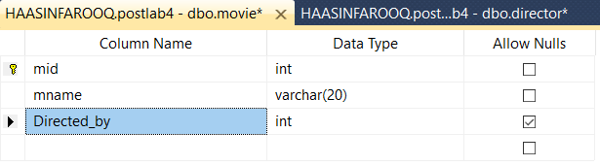

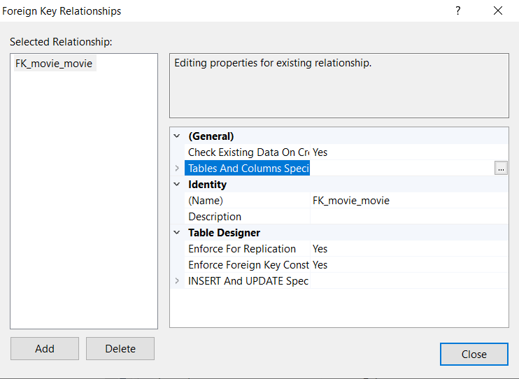

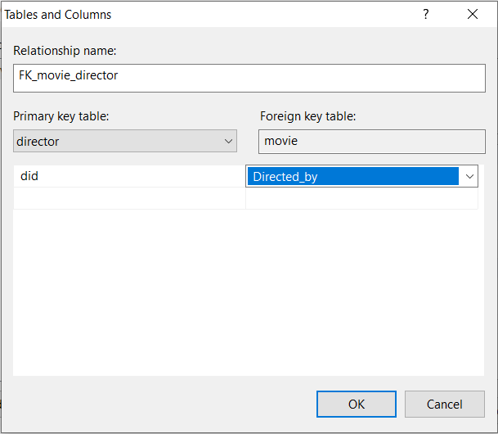

- Explore how Identity column works in SQL server, give the SQL DDL statement to add a column called Srno in movie table which would be an identity column

alter table movie add srno int identity(1,1)

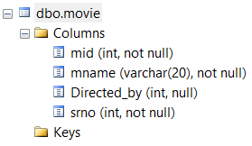

- Give the command needed to make the srno column added above a unique key for the table.

- List the main differences between truncate and delete commands

